**CRYPTONITE**

**OVERTHEWIRE: BANDIT**

*TASK PHASE 1*

**WRITE-UP**

NAME: Kunal Komre

REGISTRATION NUMBER: 230932186

So before starting the Task Phase, I first learnt about the basics of Linux and its working and about cyber security and its importance.

As per the instructions I was required to install Linux OS such as Ubuntu. But since I am a beginner in these things, I used other alternatives to carry out the Task Phase.

I installed WSL to play the game, since directly downloading Ubuntu or any Unix based OS seemed like a big task to me yet.

I referred to some YouTube videos and some articles about how to install WSL.

Here some videos I referred to:

* <https://youtu.be/YByZ_sOOWsQ?si=KmpMPM9vSB5le7tJ>
* <https://youtu.be/wjbbl0TTMeo?si=SrSREmn_6wRGlDBW>
* <https://learn.microsoft.com/en-us/windows/wsl/install>

Here is a screenshot of the me setting up the account and password.

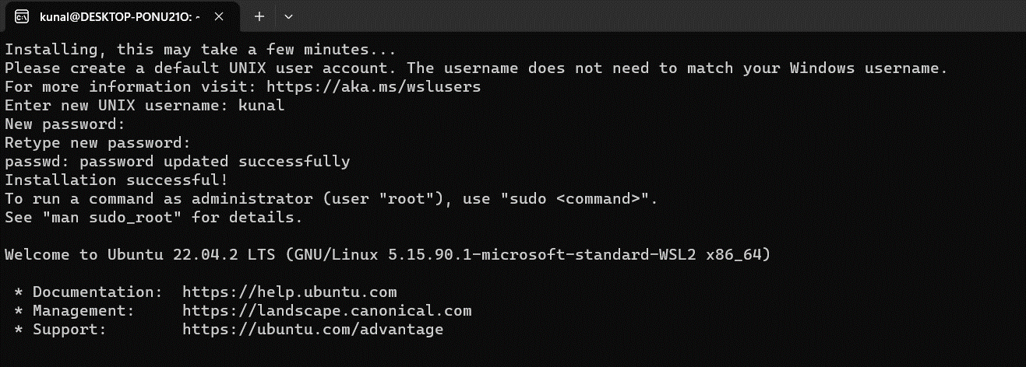

*OVERTHEWIRE: BANDIT*

The Bandit Wargame aims to improve our cybersecurity and Linux skills by solving challenges from OverTheWire.

While solving all the levels, I was stuck at various problems.

I had to read the *Helpful Reading Material* and the various new commands and their purposes that were used to solve the level. Many commands such as *ls, cat, sort, grep, uniq, etc..* were used to go to the next level. Whenever I got stuck, I had to refer to many Google to learn about a new command that was further used to solve the level.

Some sites that I used are:

* <https://linuxhint.com/>
* <https://www.geeksforgeeks.org/>
* https://www.youtube.com/ (to learn about certain commands)
* https://github.com/

I have mentioned the commands along with their definition that I used. While playing, I got the idea of Linux and its basics and how directories work. I also learnt about the syntax and commands used to correctly show the results.

I have written about the I passed each level, along with the commands used and some mistakes I made along the way.

***LEVEL 0***

The game starts at LEVEL 0. The goal of this level is for us to log into the game using SSH.

SSH, also known as Secure Shell or Secure Socket Shell, is a network protocol that gives users, particularly system administrators, a secure way to access a computer over an unsecured network. SSH also refers to the suite of utilities that implement the SSH protocol.

I used the *ssh* command to log into the network. The port, username and password were already given. I had to learn the format with which you can enter the server. As seen in the image, I made mistakes before correcting it up and entering the right way.

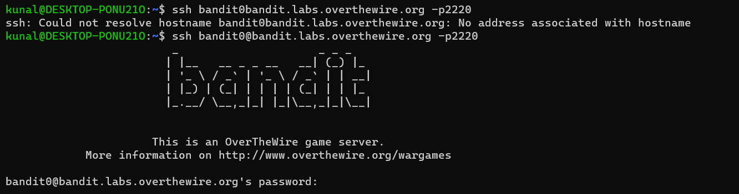

One new thing that I learned about Linux is that the password typed is not shown on the screen. It is a better alternative because it seems more secure.

After entering the password, I was logged in the server and entered LEVEL 1

***LEVEL 1***

***LEVEL GOAL:*** The password for the next level is stored in a file called **readme** located in the home directory. Use this password to log into bandit1 using SSH. Whenever you find a password for a level, use SSH (on port 2220) to log into that level and continue the game.

For this level I had to learn about different commands operated by Linux.

*COMMANDS USED:*

* “ls” – used to list the contents from the directory of the server
* “cat” – used to concatenate files and print on the standard output

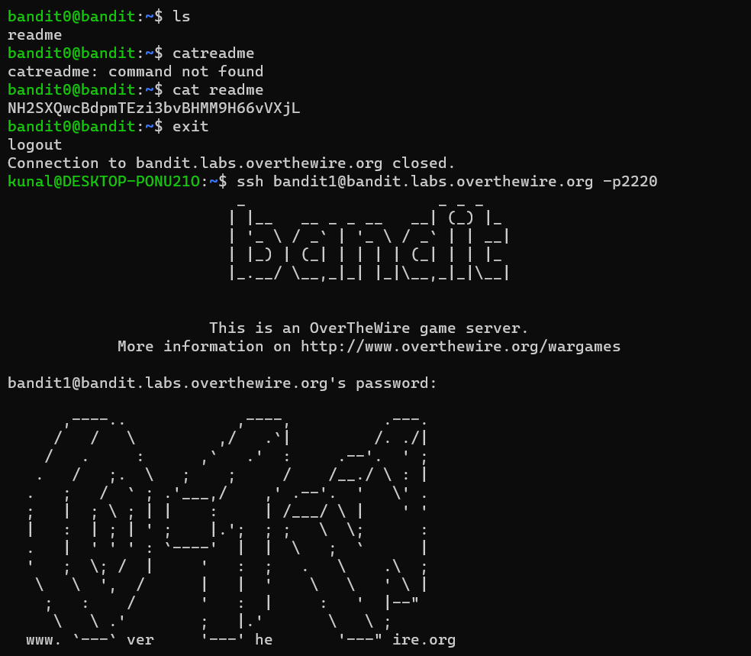

After using the *ls* command, the list directory contents were shown. It only consisted of one file named *readme*. Then I used the *cat* command to concatenate files and print on the standard output. The password to log on the next level was shown.

***LEVEL 2***

***LEVEL GOAL:*** The password for the next level is stored in a file called **-** located in the home directory.

*COMMANDS USED:*

* “’ls -la” - To get a full list of hidden files, type **ls -la** in your terminal. The output displays information about the user, size of the file, and date and time of modification.
* “cat” - used to concatenate files and print on the standard output.

The directory name is “-“ which you cannot type directly after *cat* because it gives error as “-“ is also used for another command. So to concatenate the file we need to use cat < - and cat ./- command to get the password.

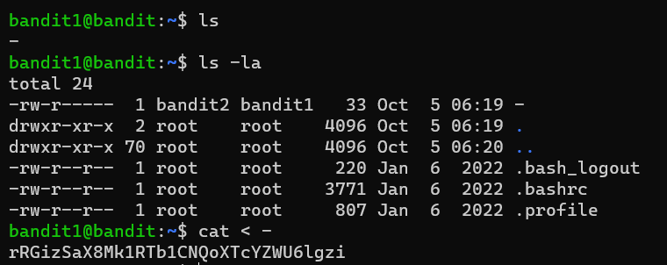

Using “cat < -“ we were able to read the “-“ file and the password was shown.

Now we can move onto the next level

***LEVEL 3***

***LEVEL GOAL:*** The password for the next level is stored in a file called **spaces in this filename** located in the home directory

*COMMANDS USED:*

* *“ls -alps”* ls -alps is the same as ls -a -l -p -s

-a: All files are being presented (even if they start if a dot)

-l: The files are being presented in a listing format

-p: A slash (/) is being appended to all directories

-s: The size of each file is being shown

* *“cat”*

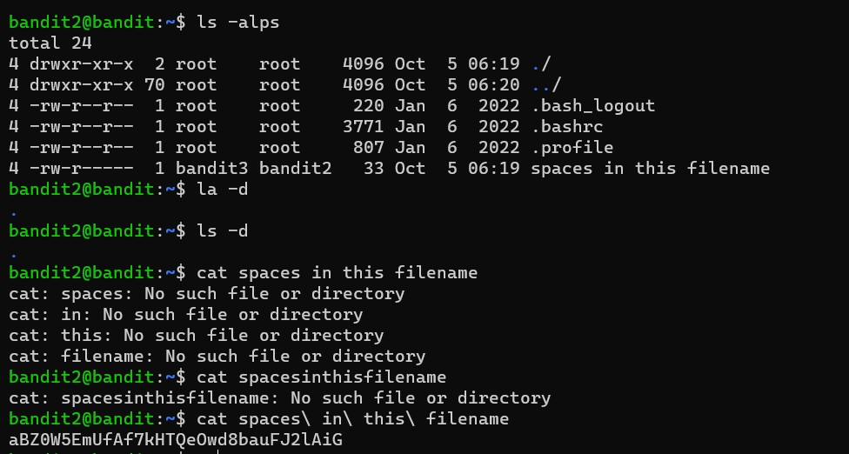

Now using the cat command and entering the name of the file produced error (as shown in the picture). To avoid error, I used “\”.

Using “\” instead of spaces removed the error and we were able to see the password in it.

Now we move on to the next level.

***LEVEL 4***

***LEVEL GOAL:*** The password for the next level is stored in a hidden file in the **inhere** directory.

*COMMANDS USED:*

* “ls -la”
* “cat”
* “cd” – It is used to change the working directory

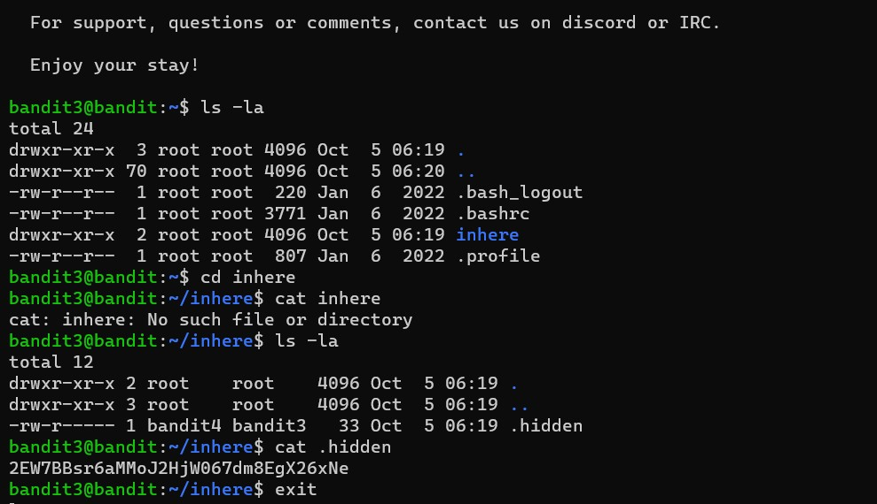

To read the hidden file, I used the *cd* command. It is used to change the working directory. It allowed me to change my directory to the file *inhere*. After that I tried to use the *cat* command to read the files of *inhere* which was wrong since we are already in the *inhere* directory. I again used *cat* to read the *.hidden* directory. The password was shown next.

***LEVEL 5***

***LEVEL GOAL:*** The password for the next level is stored in the only human-readable file in the **inhere** directory.

*COMMANDS USED:*

* “file”: determine file type
* “cat”
* “ls” 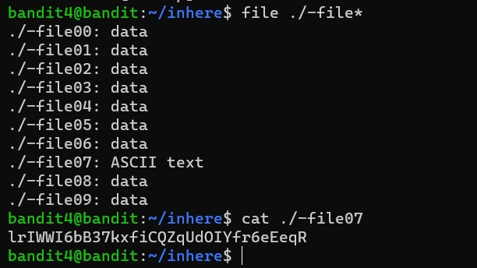

So for this level, I used *ls*  to show the list directory, but it showed the similar results and I was not able to guess which file contained the password. So I used the *file* command along with *\** command to display all files types. It showed that one file contained ASCII text. So I used *cat* to display the password of that directory.

Now onto the next level.

***LEVEL 6***

***LEVEL GOAL:*** The password for the next level is stored in a file somewhere under the **inhere** directory and has all of the following properties:

* human-readable
* 1033 bytes in size
* not executable

*COMMANDS USED:*

* “ls”
* “cat”
* “find -size”
* “cd”

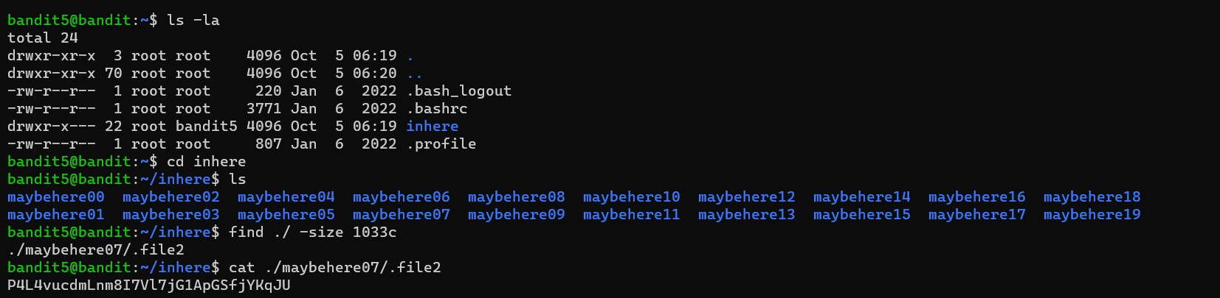

In this level, I used *ls* to display files. Then used *cd* to change directory to *inhere*. The files in this directory were of same types and we had to find in which file it contained the password. In the question it was given that the file is of size 1033 bytes/ 1033c (bytes written as c here). I then used the *find* command to find the file and also specified its size (./ -size 1033c). After specifying the size only, the password was shown.

I could have also specified that the file was not executable and was in ASCII text/ human readable format to get the same result.

Now onto the next level.

***LEVEL 7***

***LEVEL GOAL:*** The password for the next level is stored **somewhere on the server** and has all of the following properties:

* owned by user bandit7
* owned by group bandit6
* 33 bytes in size

*COMMANDS USED:*

* “ls”
* “find ./size”

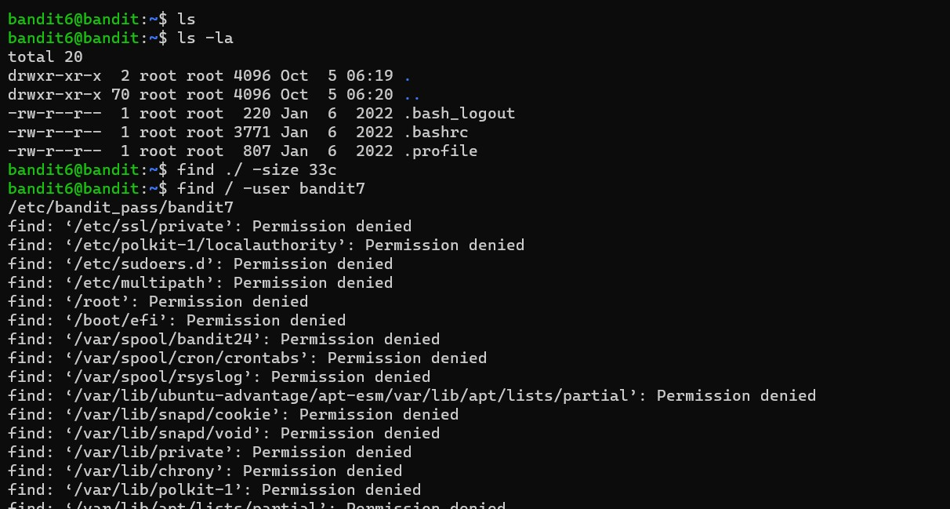

On using *ls* a lot of directories are shown. I tried to find the file with password using *find* *./size* and the *user* command but failed.

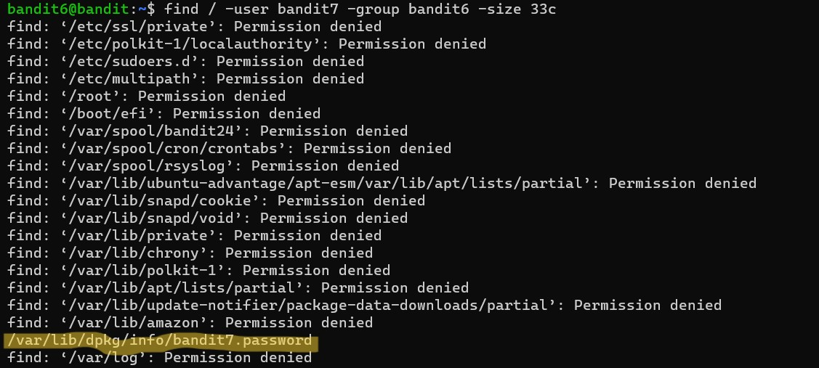

I used all the information given in the question to find the specified file( user, group, size). All of them showed a lot of data. I then studied the file names and found the address for the password(as highlighted).



I copied the file address and used *cat* to find password.

***LEVEL 8***

***LEVEL GOAL:*** The password for the next level is stored in the file **data.txt** next to the word **millionth**

*COMMANDS USED:*

* ls
* cat
* grep - searches a file for a particular pattern of characters, and displays all lines that contain that pattern

Showed the directory using *ls.* Used *cat* to read data.txt. It showed a lot of text but not the password. The password is stored next to the word **millionth** so I used *grep* along with *cat* to filter the text and we found the password next to word millionth.

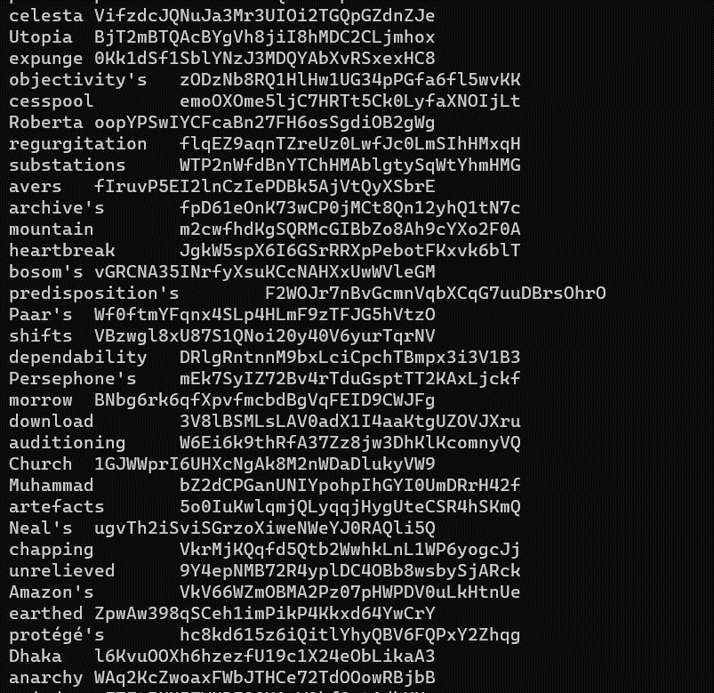

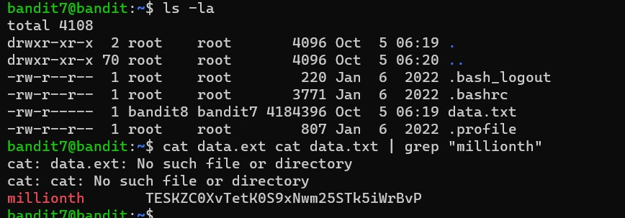

I made a mistake while typing and it did not show the expected at first but after correcting data.ext as data.txt the expected result was shown.

***LEVEL 9***

***LEVEL GOAL:*** The password for the next level is stored in the file **data.txt** and is the only line of text that occurs only once

*COMMANDS USED:*

* ls
* cat
* sort
* uniq
* sort

Using *ls* and *cat* on data.txt shows the following result

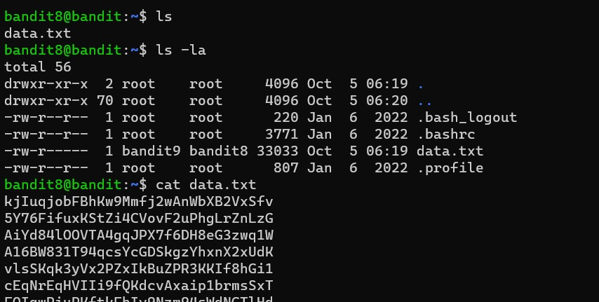

There is a lot of text. I first tried with the *sort* command, to arrange the data. But even after that it was lot of data. I had to check every single line to see if it was repeated or not.

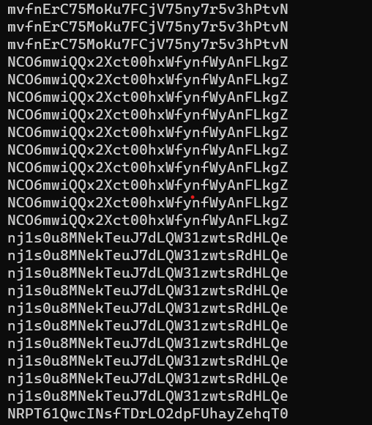

To get better results, I used the *uniq* command alond with *-c*  to get the text along with number of times it was repeated.

On entering it, the password was shown along with number of times it had beeen repeated. All other text was repeated 10 times but the password was repeated only once.

The password is shown in the image below.

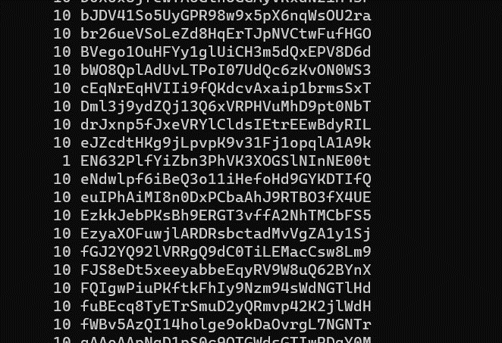

***LEVEL 10***

***LEVEL GOAL:*** The password for the next level is stored in the file **data.txt** in one of the few human-readable strings, preceded by several ‘=’ characters.

*COMMANDS USED:*

* ls
* cat
* grep
* strings - return each string type of characters that are printable in the file

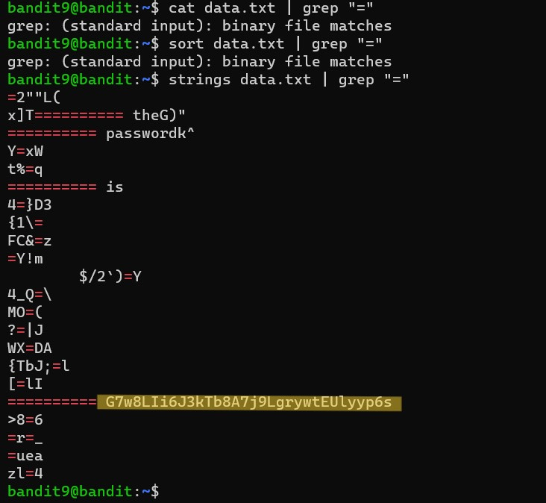

I previously tried to *cat* along with grep but it did not show password because cat processes the non printable characters and output it to the terminal but strings ignore them.

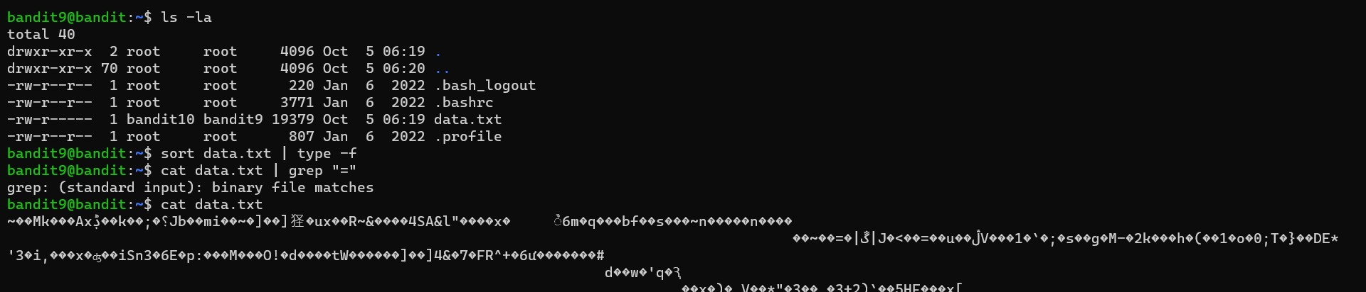

This was result I was getting when I used *cat.* (bunch various characters)

The password is highlighted in the previous image. Now onto the next level

***LEVEL 11***

***LEVEL GOAL:*** The password for the next level is stored in the file **data.txt**, which contains base64 encoded data.

*COMMANDS USED:*

* ls
* car
* base64: You can use different types of options with base64 command. Data can be taken from any file or standard input while encoding or decoding. After encode or decode, you can send the output in a file or print the output in the terminal.

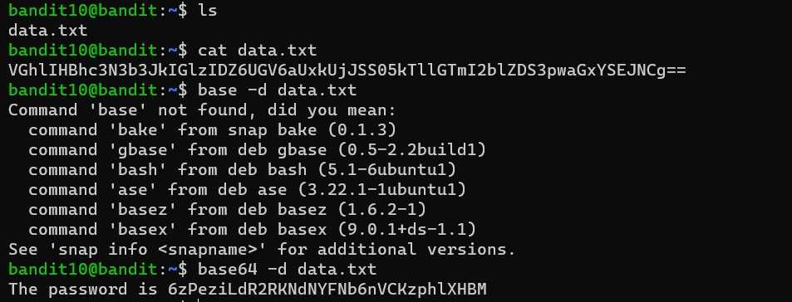

*-d* is used to decode the base64 code.

The converted text shows the password.

**LEVEL 12**

***LEVEL GOAL:*** The password for the next level is stored in the file **data.txt**, where all lowercase (a-z) and uppercase (A-Z) letters have been rotated by 13 positions,

*COMMANDS USED:*

* ls
* cat
* tr

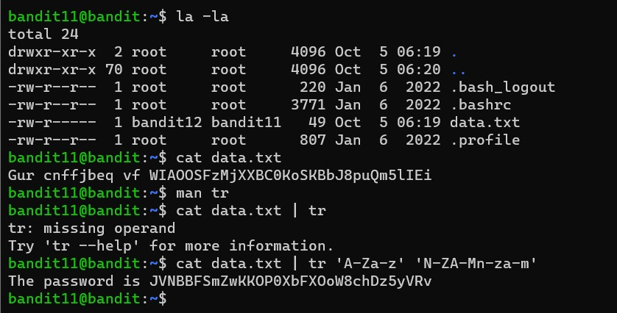

In this level, I used the command *tr ‘A-Za-z’ ‘N-ZA-Mn-za-m’*  to change the text in readable format

**LEVEL 13**

***LEVEL GOAL:*** The password for the next level is stored in the file **data.txt**, which is a hexdump of a file that has been repeatedly compressed. For this level it may be useful to create a directory under /tmp in which you can work using mkdir. For example: mkdir /tmp/myname123. Then copy the datafile using cp, and rename it using mv (read the manpages!)

*COMMANDS USED:*

* ls
* cat
* cd
* cp - copy files and directories
* mv - move (rename) files
* gzip - compress or expand files
* xxd - make a hexdump or do the reverse

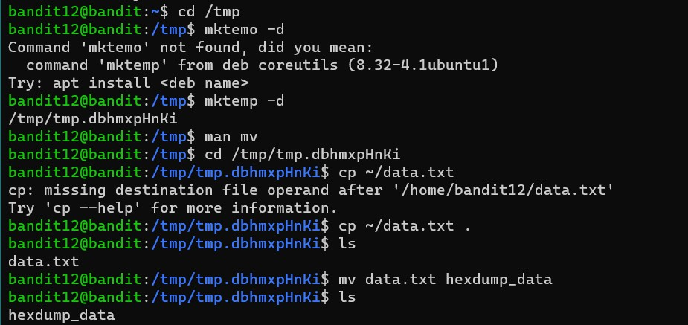

This level was the most trickiest level for me. It involved extraction and decompressing the hexdump.’ I am still not sure if I understood fully what I did here.

I had to first make a temporary folder and then move and copy the data.txt file in their.

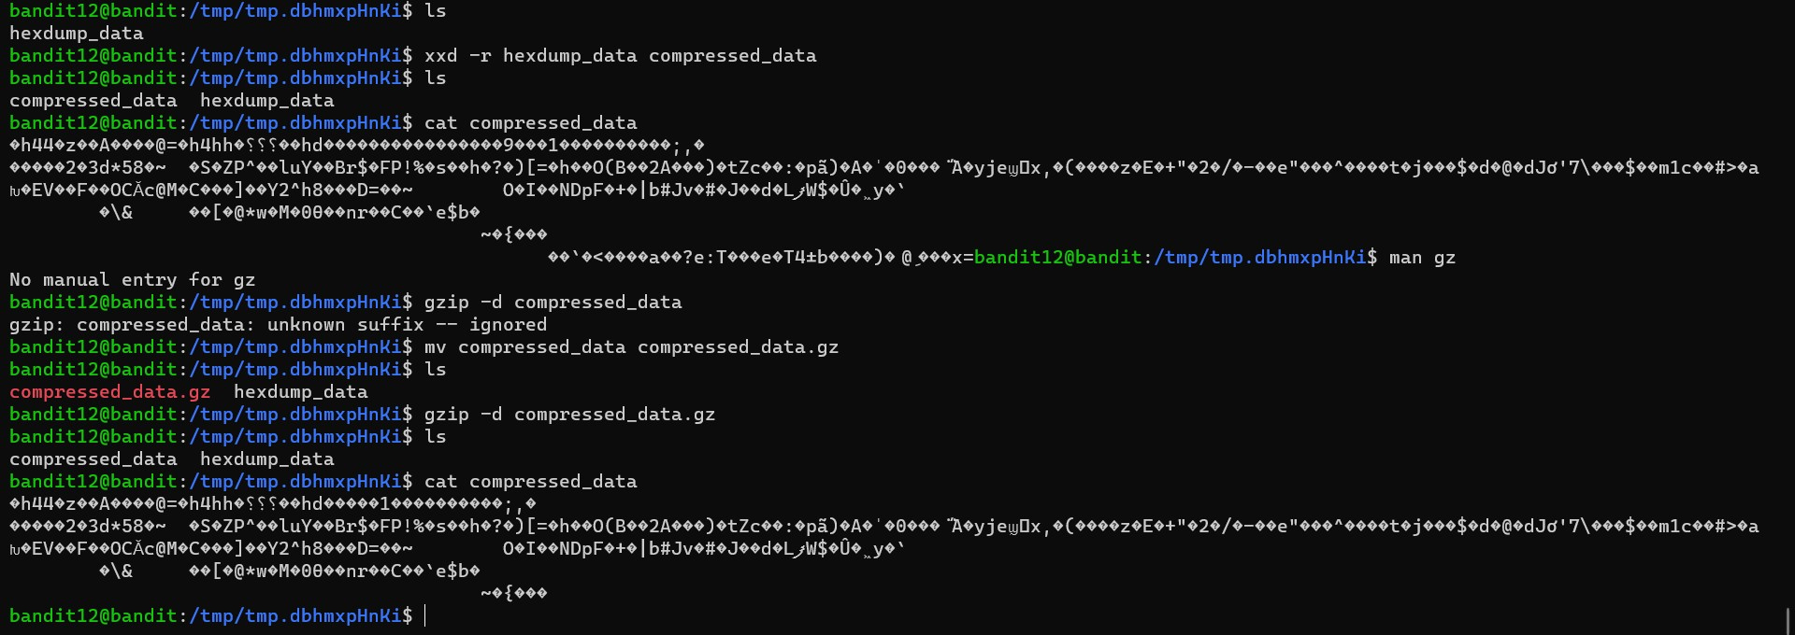

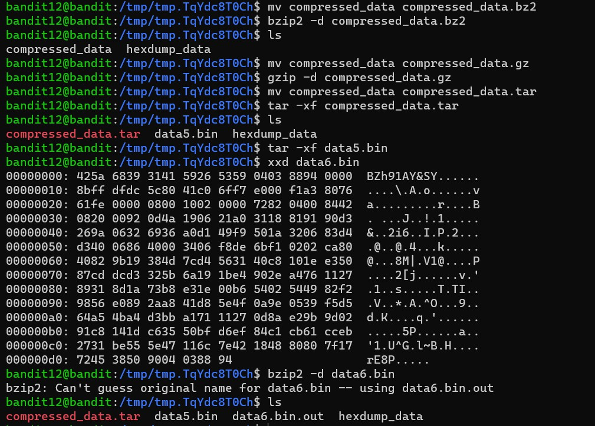

I copied the data.txt from the home directory (~) to the created directory in ’tmp’. Because I already moved into the directory I used ‘.’ as a relative path, meaning the file will be copied with the same name into the current working directory. Finally, I used mv to rename the data.

we revert the hexdump and get the actual data.

we can add the correct file ending, by renaming the file and decompress the file with gzip -d:

xxd shows that it is ‘gzip’ compressed again. So we repeat the previous steps, renaming and decompressing.

Using either cat compressed_data or xxd compressed_data | head (‘head’ to only get the first 10 lines), we can see the ‘data5.bin’ string, which is a filename.

use tar to extract the file:

‘data5.bin’ seems to be another archive with a file called ‘data6.bin’. So we extract the file again.

‘data6.bin.out’ shows another file name ‘data8.bin’ again. So we extract this file.

Finally, we have to do one more decompression with gzip and we get a readable file with the password.

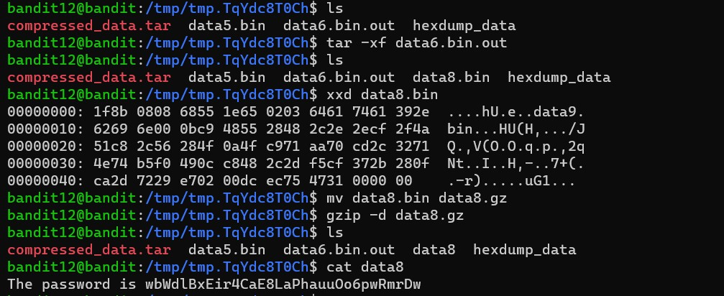

**LEVEL 14**

***LEVEL GOAL:*** The password for the next level is stored in **/etc/bandit_pass/bandit14 and can only be read by user bandit14**. For this level, you don’t get the next password, but you get a private SSH key that can be used to log into the next level.

*COMMANDS USED:*

* chmod - change file mode bits
* ls
* cat
* scp - OpenSSH secure file copy

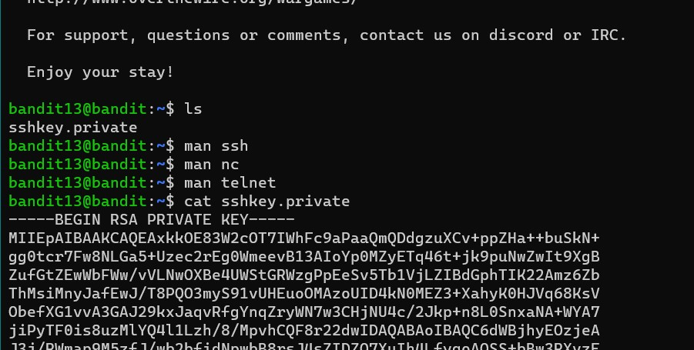

Using the *ls* command showed me that it contained a private key. On reading the private key, it showed a rsa file which will be used to log into the bandit14.

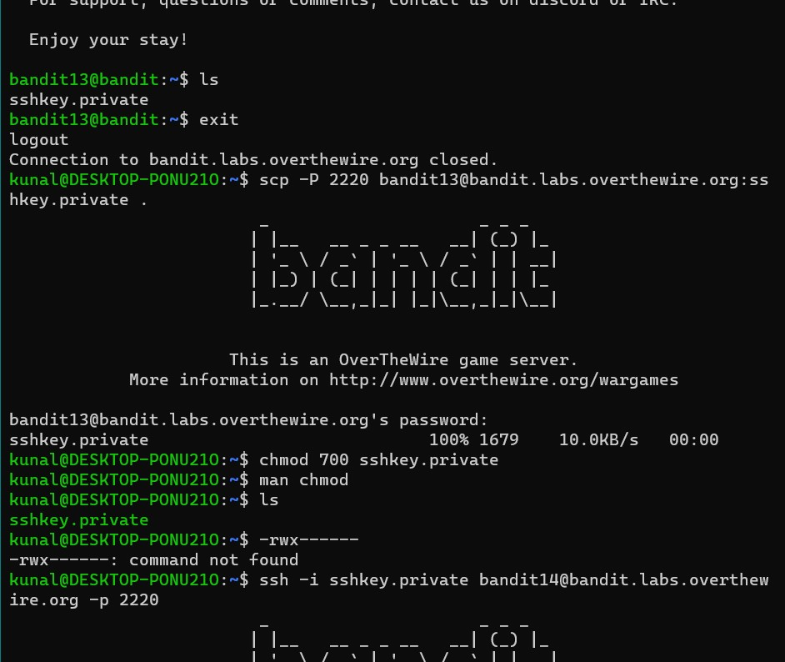

I used the *scp* command along with -I (identifier) which helped me log into bandit14 using the sskey.private key and without entering the password.

***LEVEL 15***

***LEVEL GOAL:*** The password for the next level can be retrieved by submitting the password of the current level to **port 30000 on localhost**.

*COMMANDS USED:*

* ls
* cat
* nc - arbitrary TCP and UDP connections and listens

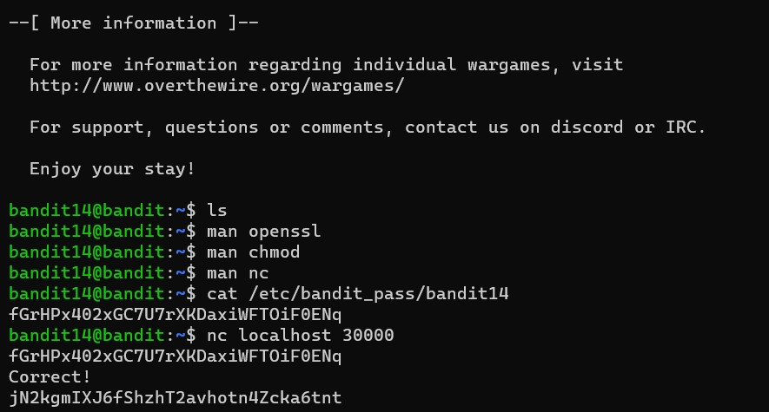

I used *nc* to connect to a new local host and the port 30000. After entering the correct password, I was shown the password for the next level.

***LEVEL 16***

***LEVEL GOAL:*** The password for the next level can be retrieved by submitting the password of the current level to **port 30001 on localhost** using SSL encryption.

*COMMANDS USED:*

* ls
* cat
* openssl - OpenSSL command line program

Used open ssl to log into localhost: 30001. It will get connected

And at end enter the password for bandit15 to get password for bandit16

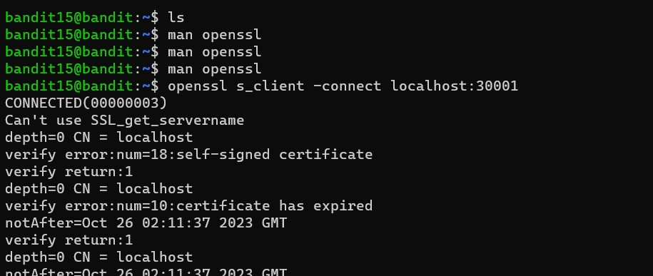

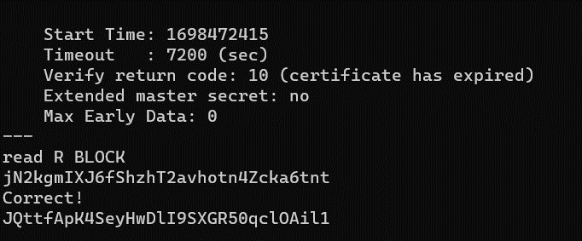

***LEVEL 17***

***LEVEL GOAL:*** The credentials for the next level can be retrieved by submitting the password of the current level to **a port on localhost in the range 31000 to 32000**. First find out which of these ports have a server listening on them. Then find out which of those speak SSL and which don’t. There is only 1 server that will give the next credentials, the others will simply send back to you whatever you send to it.

*COMMANDS USED:*

* nmap
* chmod
* cat
* ls
* ssh
* nano - nano is a small and friendly editor. It copies the look and feel of Pico, but is free software, and implements several features that Pico lacks.
* Mkdir - make directories

Used nmap to scan the ports between 31000 and 32000. It showed all the open ports that can be used. After that used -sV, to know about their service versions. Used -T4 so it takes less time.

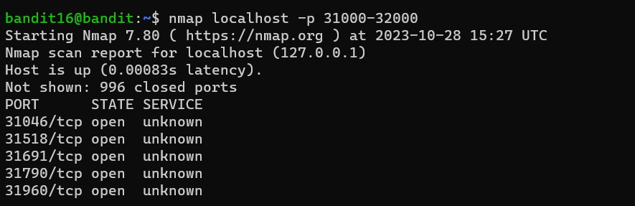

**Nmap localhost -p 31046,,31518,31691,31790,31960 -sV -T4**

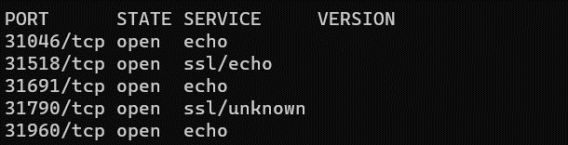



Used openssl -connect on localhost: 31790 to get the private key

(I had already opened other ports but they did not show the desired results)

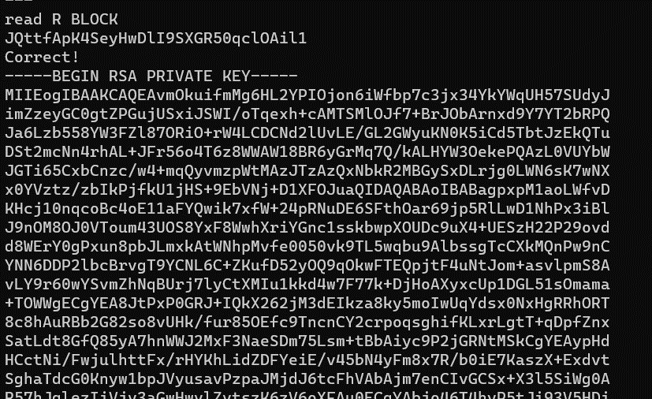

After getting the rsa private key, I went to tmp folder and made a directory named game111. I will then use Nano and paste the private key on it to be used later.I then used chmod to change permissions so that only the user can see and rewrite it and not others.

Used ssh and -I using the private key to get access to the next bandit level.

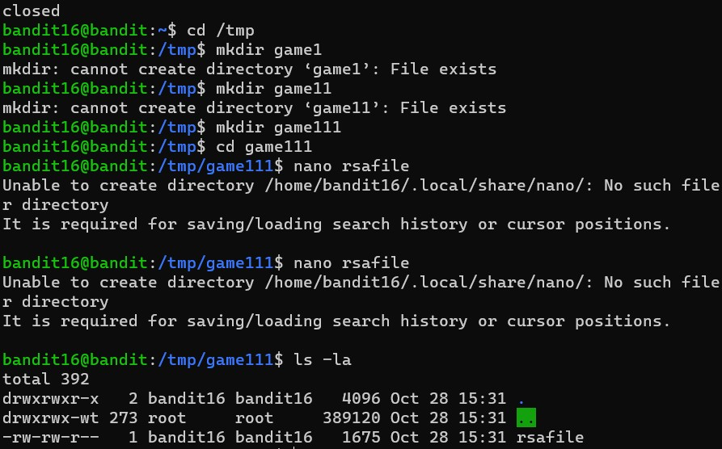

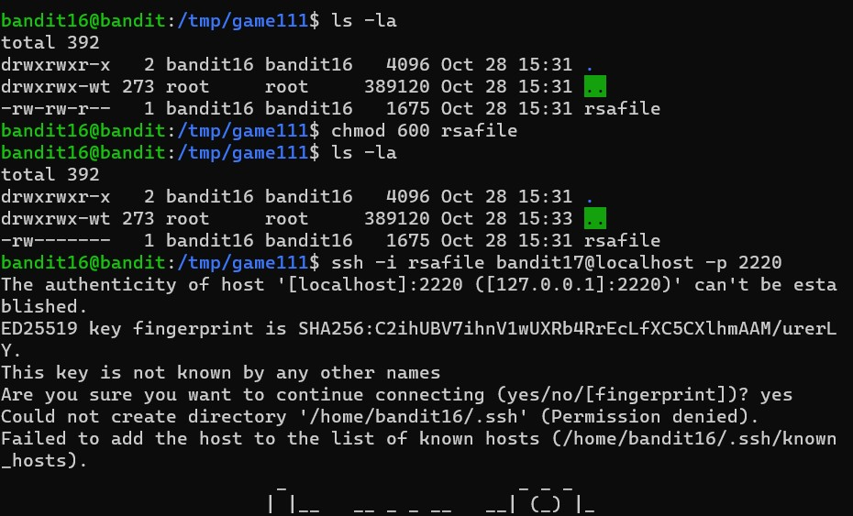

***LEVEL 18***

***LEVEL GOAL:*** There are 2 files in the homedirectory: **passwords.old and passwords.new**. The password for the next level is in **passwords.new** and is the only line that has been changed between **passwords.old and passwords.new**

***COMMANDS USED:***

* cat
* ls
* diff – diff

On using *ls* command I found that there are two passwords, password.new and password.old. So I used the *diff* command to compare the two home directories, since the difference between them shows the password for the next level.

After using the diff, I got the password

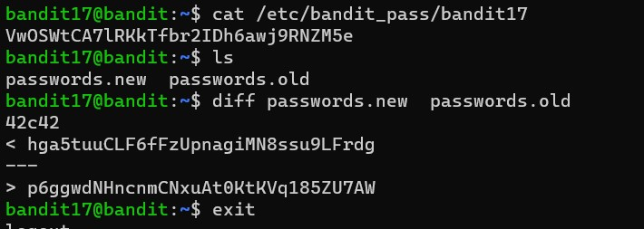

***LEVEL 19***

***LEVEL GOAL:*** The password for the next level is stored in a file **readme** in the homedirectory. Unfortunately, someone has modified **.bashrc** to log you out when you log in with SSH.

*COMMANDS USED:*

* ls
* ssh

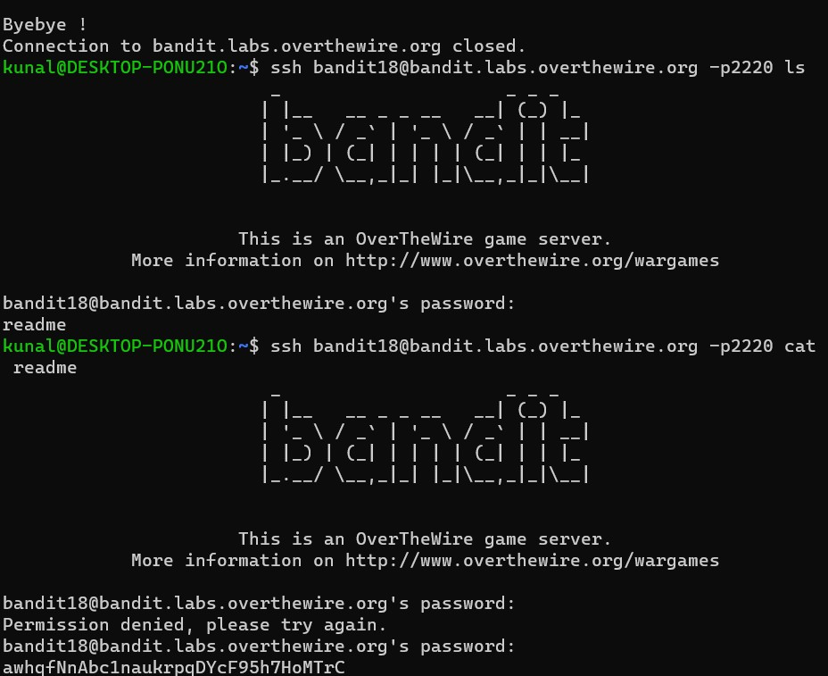

For this level, I had to directly use the *ls* and *cat* command along with the ssh command to get the password.

***LEVEL 20***

***LEVEL GOAL:*** To gain access to the next level, you should use the setuid binary in the homedirectory. Execute it without arguments to find out how to use it. The password for this level can be found in the usual place (/etc/bandit_pass), after you have used the setuid binary.

*COMMANDS USED:*

* ls
* do
* id - print real and effective user and group IDs

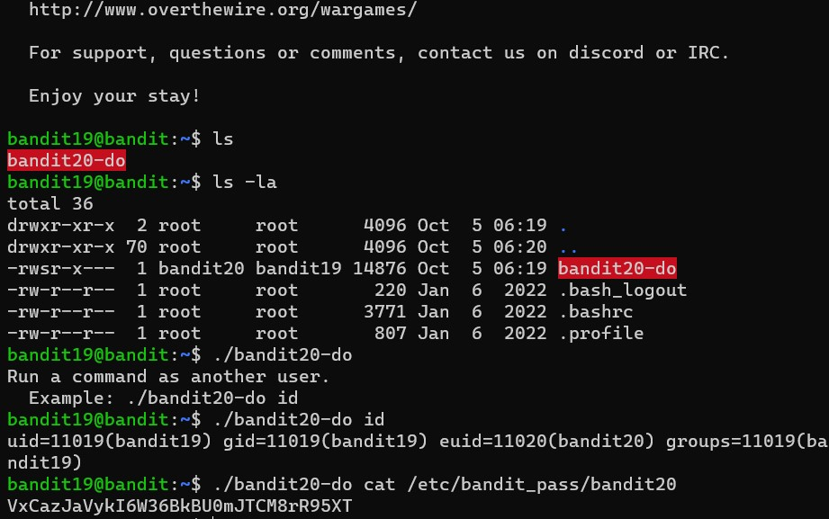

For level 20, It was given that I could execute commands on bandit20 while being logged into bandit19. But for that I need to to use the setuid binary.

I used ./ (dot slash) command to look into the directory. As shown in the image, it allowed me to run commands as another user.

I used *id* as just an example

Used *cat /etc.bandit_pass/bandit20* to get the password.

***LEVEL 21***

***LEVEL GOAL:***  There is a setuid binary in the homedirectory that does the following: it makes a connection to localhost on the port you specify as a commandline argument. It then reads a line of text from the connection and compares it to the password in the previous level (bandit20). If the password is correct, it will transmit the password for the next level (bandit21).

*COMMANDS USED:*

* ls
* nc
* ssh



For this level, I had to log into bandit 20 in two different terminals and then connect both to get the password.

Used *nc -lvp* (listen verbose port) to establish connection. We can then what is happening on both ports and connection is established. It then reads the passwords entered on both terminals and if the passwords matches, gives the password for the next level.